

Midterm Project Report

Customer Click-Through-Rate Prediction

Qianhui Rong

11/12/2018

# A. Abstract

This analysis project is conducted based on the Tesco purchase history data. The goal is to build an appropriate model to predict the advertisements’ click-through-rate for each of the customers in Tesco’s database. This has been done with multinomial model, logistic model and multilevel mixed effect model. A problem named “rare event” problem or “rare event problem” has arose during modeling process. Some methods have been used to tackle this problem, but their performance is not up to the expectation, which leaves a wide exploring space for future analysis on this data.

# B. Introduction

Click-through_rate(CTR) is the percentage rate at which people click on a particular ad when online. A critical step to improve CTR is to target the right group of customers for each kind of advertisement. Therefore, exploring the relation between features of customers (for example, demographic characteristics and purchase preferences) and whether they have clicked through this advertisement is important. The most common and efficient method is logistic regression, predicting the probability of a certain group of people clicking a link. Also, there are some machine learning methods popular for this problem: Gradient Boosting Decision Tree, Factorization Mechines, etc.

# C. Method

## 1. Data source

The data is obtained from <https://www.kaggle.com/linkonabe/tesco-marketing-content>. It’s shared by Tesco company, which is a supermarket market leader in the UK. The company releases some marketing content cards each year, and in this dataset, we have 9 of them marked as content_1 to content_9. For each content card, 1 means the customer clicked on the card, 0 means the customer viewed the card but didn’t click, NA means the user was never shown the card. The dataset also shares its customers’ purchase history in different kinds of shop. There are seven kinds of store: -Tesco Express: neighbourhood convenience shops -Tesco Metro: located in city centres beside railway stations -Tesco Superstore: standard large supermarkets -Tesco Extra: larger, mainly out-of-town hypermarkets -Tesco F&F: online store selling Tesco’s own clothes brand -Tesco Direct: online store selling groceries, homewares, electronics, etc. -Tesco Petrol: grocery store in petrol stations Some customers’ demographic features are also provided in the data: gender and county. Affluency is a more informative variable than county. It’s a broad categorisation of how affluent the customer is based on their postcode.

## 2. Model used

Models selected to explain the content_1 variable are:

-Multinomial Model: using content_1 without conversion or pre-processing, and keep its three levels(0,1,NA);

For the following two models, preprocessing is necessary. I’ve first tried out converting NA to 0 and leave 1 as 1, so content_1 becomes “absence of click” vs. “presence of click”, but this makes the “rare event” problem more severe(in appendix). Then I switched to eliminating the NA directly in both training set and testing set, in order to make “ones” in content_1 to have a higher proportion, compared to “zeros” in content_1(in main result section). -Logistic Model -Multilevel Mixed Effect Model

# D. Results

## Part I: EDA

### EDA on Affluency

About affluency, I’m expecting a higher amount of transactions and a higher number of transactions in regions of higher degree of affluency.

### 1. Total amount of transactions vs. Affluency

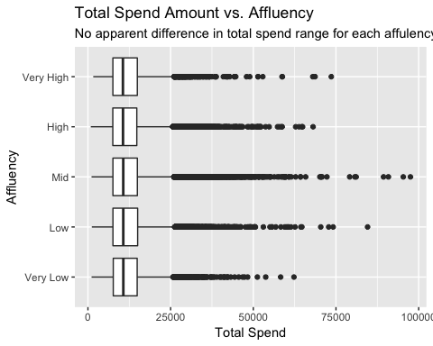

There are some points located in higher spend amount for Mid class affluency, but these points are trivial to the whole data size.  
As for the boxplots, I can’t see any apparent difference in total spend for each affluency class. The affluency should have small influence on total spend amount.

### 2. Total Number of transactions vs. Affluency

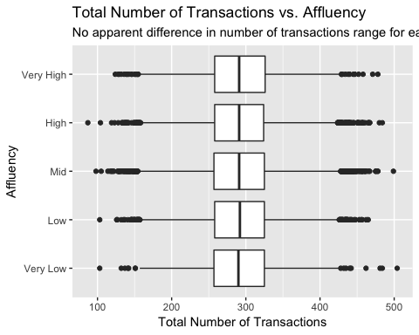

The boxplots don’t see any apparent difference in number of transactions for each affluency class. The affluency should have small influence on number of transactions.

### 3. Clicking in Different Content (1~9) vs. Affluency

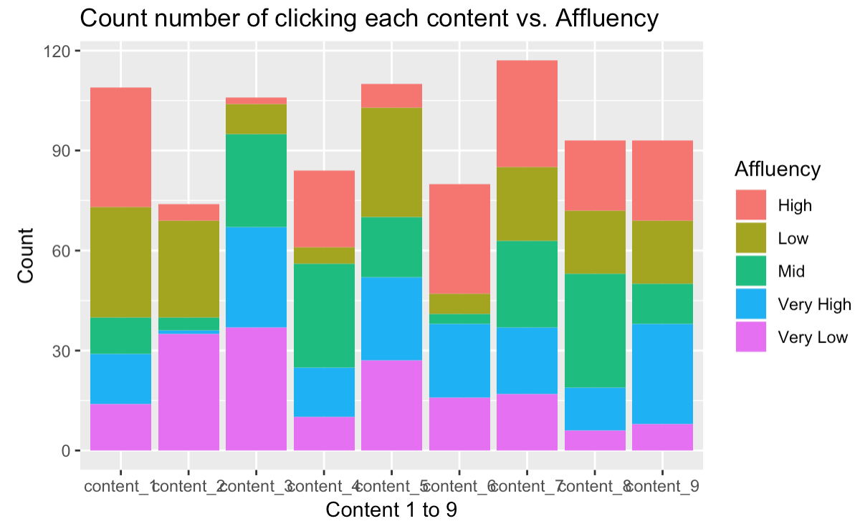

The most clicked contents are content 7 and content1, and the rest of them don't have an evident difference on count. People from different affluency regions may have some preferences towards certain contents, but hard to make sure on it.

## EDA on Gender

### 1. Total amount of transactions vs. Gender

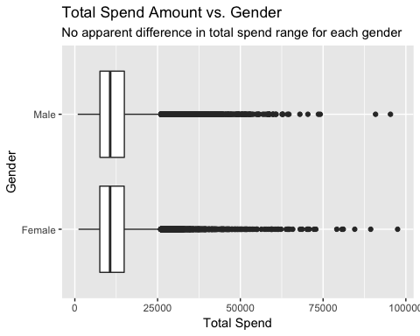

The boxplots don’t see any apparent difference in total spend for each gender class. Gender should have small influence on total spend amount.

### 2. Total Number of transactions vs. Gender

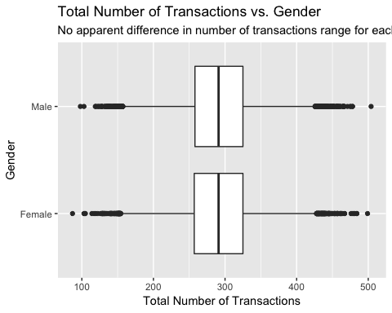

The boxplots don’t see any apparent difference in number of transactions for each gender class. Gender should have small influence on number of transactions.

### 3. Clicking in Different Content (1~9) vs. Gender

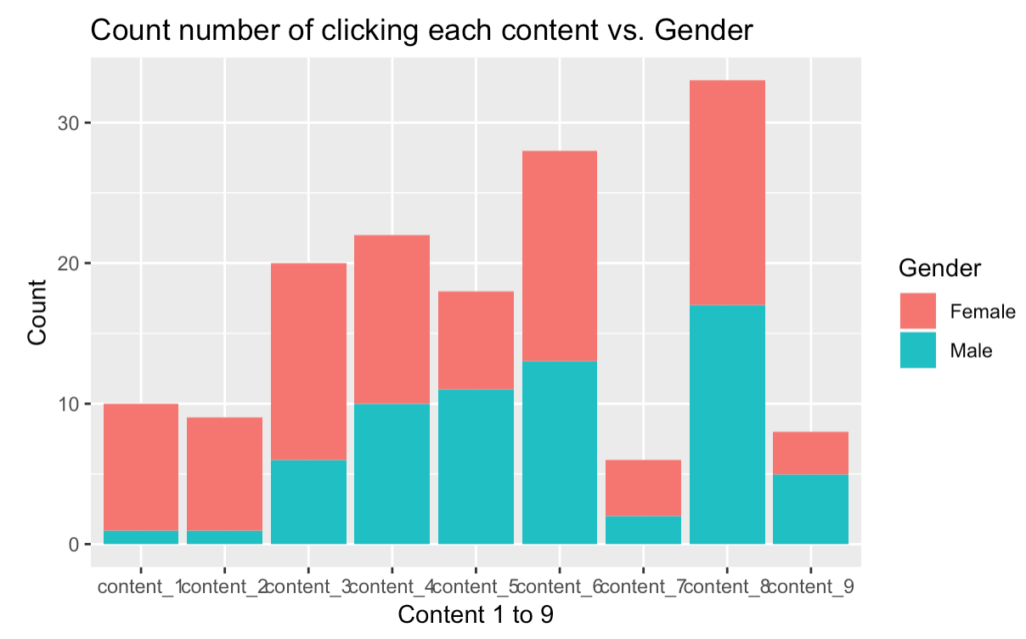

Certain contents are male dominant (content 5 and 9) but most of them are female dominant (content 1,2,3,7). We can expect contents have gender-featured.

## EDA on Contents (Clicked/Ignored/Not Informed)

### 1. Plot of amount of transactions and contents

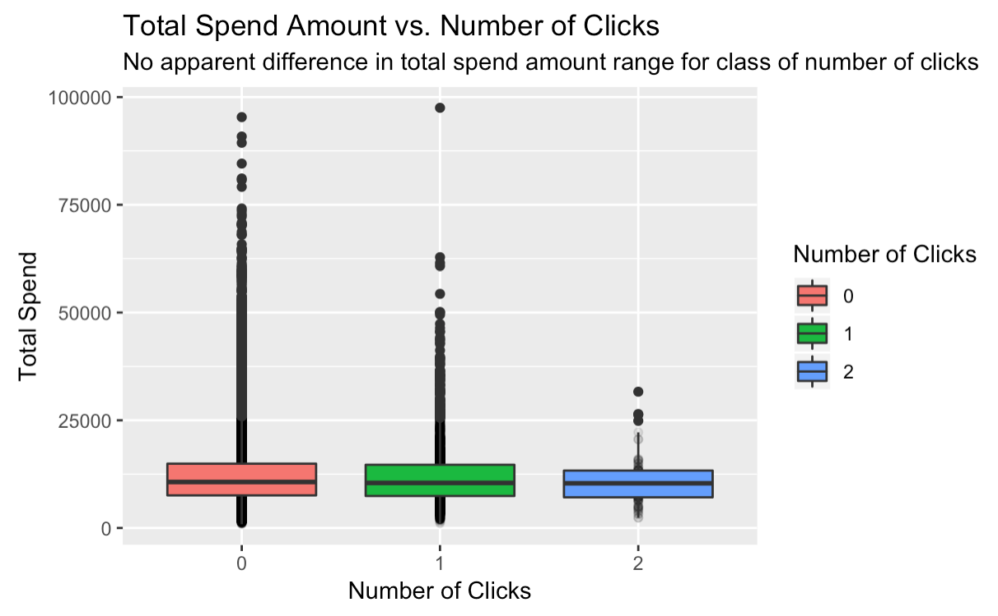

The main ranges of total spend amount for each class of number of clicks are not significantly different, while the not informed (zero) class has more points above 75,000 (the number of these points is trivial compared to the number of points below 75,000 though).

### 2. Plot of number of transactions and contents

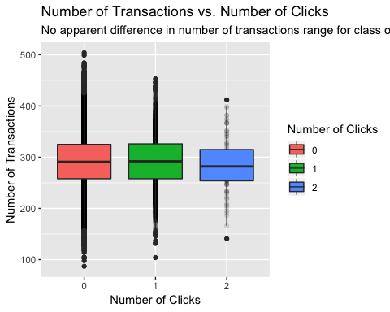

The maximums and minimums of the number of transactions for three classes of clicks are different, with the class clicked (two)’s range the smallest. However, the boxplots don’t show an apparent difference.

## Variables Correlation and Plot

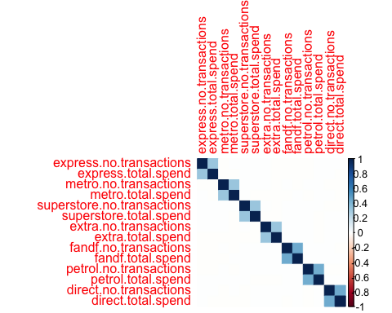

From the correlation plot, we can see that only the number of transactions and the total amount of spend from each type of store are correlated, and the variables intra-store type are not correlated at all (white on the plot).

## Part II: Modeling

In this Modeling section, I’ll use the data deleted content_1=NA observations.

### i. Multinomial Model for Contents

The content_1 is orginally a three-level response variable, and the first relevant model that came to my mind is multinomial model.

I fit a multinomial model taking content one’s clicking history (0, 1, NA: three levels) as response variable. In this case, the three possible responses are: not informed(NA) / informed but didn’t click(0) / clicked(1) have an order. To avoid problems, convert “NA” to “0”, “0” to “1”, “1” to “2”. “0” means the customers are not informed, “1” means the customers didn’t clicked, “2” means the customers have clicked.

## Call:  
## polr(formula = content_1 ~ as.factor(gender) + as.factor(affluency) +   
## log(express.total.spend + 1) + log(express.no.transactions +   
## 1) + log(metro.total.spend + 1) + log(metro.no.transactions +   
## 1) + log(superstore.total.spend + 1) + log(superstore.no.transactions +   
## 1) + log(extra.total.spend + 1) + log(extra.no.transactions +   
## 1) + log(fandf.total.spend + 1) + log(fandf.no.transactions +   
## 1) + log(petrol.total.spend + 1) + log(petrol.no.transactions +   
## 1) + log(direct.total.spend + 1) + log(direct.no.transactions +   
## 1), data = data_train, Hess = T)  
##   
## Coefficients:  
## Value Std. Error t value  
## as.factor(gender)Male -0.009182 0.014160 -0.6484  
## as.factor(affluency)Low -0.025490 0.022410 -1.1375  
## as.factor(affluency)Mid -0.041716 0.018812 -2.2175  
## as.factor(affluency)Very High -0.051694 0.035447 -1.4583  
## as.factor(affluency)Very Low 0.047587 0.035519 1.3398  
## log(express.total.spend + 1) 0.002352 0.006007 0.3916  
## log(express.no.transactions + 1) -0.015385 0.014972 -1.0276  
## log(metro.total.spend + 1) 0.004984 0.005947 0.8380  
## log(metro.no.transactions + 1) 0.001624 0.014995 0.1083  
## log(superstore.total.spend + 1) 0.004705 0.005863 0.8024  
## log(superstore.no.transactions + 1) -0.003470 0.015277 -0.2271  
## log(extra.total.spend + 1) 0.006325 0.005874 1.0768  
## log(extra.no.transactions + 1) -0.017368 0.015246 -1.1392  
## log(fandf.total.spend + 1) 0.001960 0.005772 0.3396  
## log(fandf.no.transactions + 1) -0.001951 0.011345 -0.1719  
## log(petrol.total.spend + 1) -0.001046 0.006002 -0.1743  
## log(petrol.no.transactions + 1) -0.002153 0.011115 -0.1937  
## log(direct.total.spend + 1) -0.008313 0.005524 -1.5049  
## log(direct.no.transactions + 1) 0.015327 0.011846 1.2939  
##   
## Intercepts:  
## Value Std. Error t value  
## 0|1 0.1053 0.1127 0.9343  
## 1|2 5.2436 0.1231 42.5889  
##   
## Residual Deviance: 114792.93   
## AIC: 114834.93

LogLoss

## [1] 3.059993

#Calculate the probability of mis-prediction

## [1] 0.45865

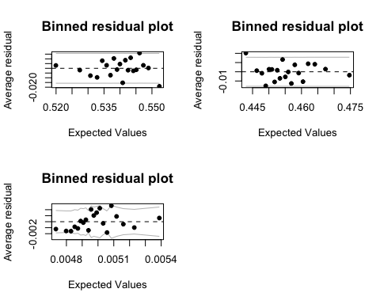

The multinomial model can be written as:

The only difference in these two formulas is the intercepts.

For this multinomial model:

1. The residual plots for three levels look acceptable, with most of the points located between two curves.
2. As for the coefficients, region and gender don’t have a large influence on the response variable, neither numbers of transactions and total amounts, because their coefficient estimates are close to zero.
3. Prediction based on this model is a little bit better than random guess, about 55% of successful prediction rate. But the problem is that the model automatically take all predictions equal to 0.

I then move on to logistic model to see if the model will be more interpretable.

To simplify the problem, I then narrow the response’s three levels to two levels by deleting NA observations in order to increase the ones proportion compared to the zeros. “0” means the customers didn’t clicked, “1” means the customers have clicked.

nrow(subset(data_train_nona,data_train_nona$content_1=="0"))

## [1] 36450

nrow(subset(data_train_nona,data_train_nona$content_1=="1"))

## [1] 399

#Now for content 1, there are 36450 ones and 399 twos.

### ii. Logistic Model

##   
## Call:  
## glm(formula = content_1 ~ as.factor(gender) + as.factor(affluency) +   
## log(express.total.spend + 1) + log(express.no.transactions +   
## 1) + log(metro.total.spend + 1) + log(metro.no.transactions +   
## 1) + log(superstore.total.spend + 1) + log(superstore.no.transactions +   
## 1) + log(extra.total.spend + 1) + log(extra.no.transactions +   
## 1) + log(fandf.total.spend + 1) + log(fandf.no.transactions +   
## 1) + log(petrol.total.spend + 1) + log(petrol.no.transactions +   
## 1) + log(direct.total.spend + 1) + log(direct.no.transactions +   
## 1), family = binomial, data = data_train_nona)  
##   
## Deviance Residuals:   
## Min 1Q Median 3Q Max   
## -0.2752 -0.1772 -0.1278 -0.1064 3.3331   
##   
## Coefficients:  
## Estimate Std. Error z value Pr(>|z|)  
## (Intercept) -3.997e+00 7.995e-01 -4.999 5.76e-07  
## as.factor(gender)Male -1.022e+00 1.135e-01 -9.003 < 2e-16  
## as.factor(affluency)Low -1.541e-01 1.574e-01 -0.979 0.327  
## as.factor(affluency)Mid -1.411e-01 1.293e-01 -1.091 0.275  
## as.factor(affluency)Very High 6.683e-02 2.358e-01 0.283 0.777  
## as.factor(affluency)Very Low -1.137e-01 2.492e-01 -0.456 0.648  
## log(express.total.spend + 1) 7.209e-02 4.486e-02 1.607 0.108  
## log(express.no.transactions + 1) -4.331e-02 1.099e-01 -0.394 0.694  
## log(metro.total.spend + 1) 1.410e-02 4.261e-02 0.331 0.741  
## log(metro.no.transactions + 1) 7.861e-03 1.084e-01 0.073 0.942  
## log(superstore.total.spend + 1) 4.233e-02 4.289e-02 0.987 0.324  
## log(superstore.no.transactions + 1) -1.346e-02 1.121e-01 -0.120 0.904  
## log(extra.total.spend + 1) 5.914e-03 4.177e-02 0.142 0.887  
## log(extra.no.transactions + 1) -1.558e-01 1.017e-01 -1.532 0.126  
## log(fandf.total.spend + 1) -9.066e-03 4.079e-02 -0.222 0.824  
## log(fandf.no.transactions + 1) 1.284e-05 7.994e-02 0.000 1.000  
## log(petrol.total.spend + 1) -3.335e-02 4.242e-02 -0.786 0.432  
## log(petrol.no.transactions + 1) 7.001e-02 7.881e-02 0.888 0.374  
## log(direct.total.spend + 1) 1.239e-02 3.931e-02 0.315 0.753  
## log(direct.no.transactions + 1) -6.420e-02 8.394e-02 -0.765 0.444  
  
## Signif. codes: 0 '***' 0.001 '**' 0.01 '*' 0.05 '.' 0.1 ' ' 1  
##   
## (Dispersion parameter for binomial family taken to be 1)  
##   
## Null deviance: 4405.1 on 36848 degrees of freedom  
## Residual deviance: 4303.0 on 36829 degrees of freedom  
## AIC: 4343  
##   
## Number of Fisher Scoring iterations: 8

#Anova test to show if adding each variable makes sense

## Df Deviance Resid. Df Resid. Dev  
## NULL 36848 4405.1  
## as.factor(gender) 1 91.465 36847 4313.6  
## as.factor(affluency) 4 1.993 36843 4311.7  
## log(express.total.spend + 1) 1 2.610 36842 4309.0  
## log(express.no.transactions + 1) 1 0.145 36841 4308.9  
## log(metro.total.spend + 1) 1 0.189 36840 4308.7  
## log(metro.no.transactions + 1) 1 0.005 36839 4308.7  
## log(superstore.total.spend + 1) 1 1.086 36838 4307.6  
## log(superstore.no.transactions + 1) 1 0.017 36837 4307.6  
## log(extra.total.spend + 1) 1 0.503 36836 4307.1  
## log(extra.no.transactions + 1) 1 2.270 36835 4304.8  
## log(fandf.total.spend + 1) 1 0.132 36834 4304.7  
## log(fandf.no.transactions + 1) 1 0.000 36833 4304.7  
## log(petrol.total.spend + 1) 1 0.018 36832 4304.7  
## log(petrol.no.transactions + 1) 1 0.777 36831 4303.9  
## log(direct.total.spend + 1) 1 0.305 36830 4303.6  
## log(direct.no.transactions + 1) 1 0.587 36829 4303.0

#LogLoss to see the difference between fitted values and actual values  
LogLoss

## [1] 4.709136

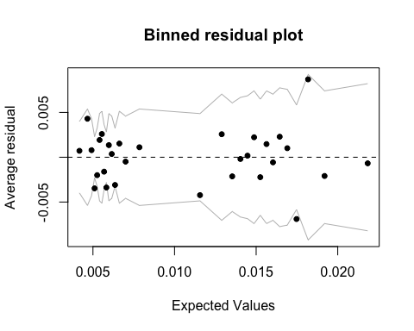

#Error table  
## y_hat=0 y_hat=1  
## y=0 0.98917203 0  
## y=1 0.01082797 0

#Predictions plot

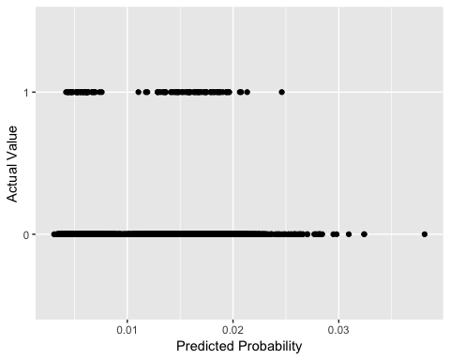

For this logistic model:

* 1. Comparing the null deviance and residual deviance, we can see that the model has been improved by adding new variables.
  2. About the coefficients, gender is the most influencial variable to the response variable, and the others are still not explaining it well.
  3. From the ANOVA test, even though the deviance is not improving drastically, as I added each variable, the deviance does decrease (but of small amount).
  4. LogLoss is a value that we want to minimize signifying that the model is more accurate. The LogLoss in this model is higher than that of multinomial model.
  5. Binned residual plot here looks normal, with all points between lines and symmetrically distributed above and below zero.
  6. The error table is telling a big problem, as the one I’ve observed from the multinomial model before. The model is having a really high successful prediction rate, 99.5%. Simply because that it is predicting all the test observations to be zero, because the original training dataset has only less than 0.05% which has The number of customers who have clicked through is really low. I’ll deal with this in the next section “Rare event problem”.
  7. The prediction plot also illustrates the last problem. We have the predicted probability not higher than 0.02, which we can approximate to a probabilitu of zero, but there are a number of points of one.

To deal with logistic regression’s “rare event problem”: We only have 399 “ones” in data_train for content_1, which is relatively rare, about 1%. I’ll try three most popular methods to deal with this kind of “*Rare Event Problem*”:

#### a. brglm: Bias Reduction in Binomial-Response Generalized Linear Models

##   
## Call:  
## brglm(formula = content_1 ~ as.factor(gender) + as.factor(affluency) +   
## log(express.total.spend + 1) + log(express.no.transactions +   
## 1) + log(metro.total.spend + 1) + log(metro.no.transactions +   
## 1) + log(superstore.total.spend + 1) + log(superstore.no.transactions +   
## 1) + log(extra.total.spend + 1) + log(extra.no.transactions +   
## 1) + log(fandf.total.spend + 1) + log(fandf.no.transactions +   
## 1) + log(petrol.total.spend + 1) + log(petrol.no.transactions +   
## 1) + log(direct.total.spend + 1) + log(direct.no.transactions +   
## 1), family = binomial, data = data_train_nona)  
##   
##   
## Coefficients:  
## Estimate Std. Error z value Pr(>|z|)  
## (Intercept) -3.8393754 0.7860728 -4.884 1.04e-06  
## as.factor(gender)Male -1.0185855 0.1120838 -9.088 < 2e-16  
## as.factor(affluency)Low -0.1531079 0.1555150 -0.985 0.325  
## as.factor(affluency)Mid -0.1438760 0.1278681 -1.125 0.261  
## as.factor(affluency)Very High 0.0820907 0.2317607 0.354 0.723  
## as.factor(affluency)Very Low -0.0945375 0.2444770 -0.387 0.699  
## log(express.total.spend + 1) 0.0707130 0.0443016 1.596 0.110  
## log(express.no.transactions + 1) -0.0483935 0.1082230 -0.447 0.655  
## log(metro.total.spend + 1) 0.0127495 0.0420744 0.303 0.762  
## log(metro.no.transactions + 1) 0.0027111 0.1067234 0.025 0.980  
## log(superstore.total.spend + 1) 0.0408004 0.0423360 0.964 0.335  
## log(superstore.no.transactions + 1) -0.0181540 0.1103970 -0.164 0.869  
## log(extra.total.spend + 1) 0.0043457 0.0412364 0.105 0.916  
## log(extra.no.transactions + 1) -0.1596766 0.1002229 -1.593 0.111  
## log(fandf.total.spend + 1) -0.0102178 0.0402931 -0.254 0.800  
## log(fandf.no.transactions + 1) -0.0003046 0.0789415 -0.004 0.997  
## log(petrol.total.spend + 1) -0.0344171 0.0418980 -0.821 0.411  
## log(petrol.no.transactions + 1) 0.0694901 0.0778077 0.893 0.372  
## log(direct.total.spend + 1) 0.0112770 0.0388238 0.290 0.771  
## log(direct.no.transactions + 1) -0.0644028 0.0829091 -0.777 0.437  
  
## Signif. codes: 0 '***' 0.001 '**' 0.01 '*' 0.05 '.' 0.1 ' ' 1  
##   
## (Dispersion parameter for binomial family taken to be 1)  
##   
## Null deviance: 4316.3 on 36848 degrees of freedom  
## Residual deviance: 4303.3 on 36829 degrees of freedom  
## Penalized deviance: 4196.796   
## AIC: 4343.3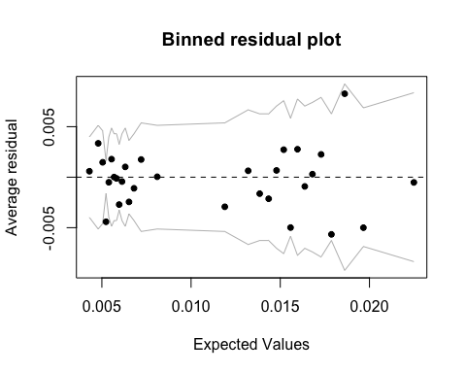

#Error table

## y_hat=0 y_hat=1  
## y=0 0.98917203 0  
## y=1 0.01082797 0

#Predictions plot

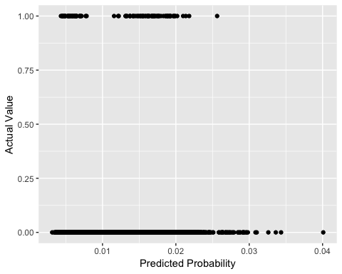

From this brglm model:

1. We’re seeing similar model outputs in summary, given that I’ve kept all the same independent variables.
2. The error table shows similar results and the same problem as before; So does the prediction test.
3. This model is not a good remedy for our problem in the context.

#### b. logistf: Firth’s bias-Reduced penalized-likelihood logistic regression

## logistf(formula = content_1 ~ as.factor(gender) + as.factor(affluency) +   
## log(express.total.spend + 1) + log(express.no.transactions +   
## 1) + log(metro.total.spend + 1) + log(metro.no.transactions +   
## 1) + log(superstore.total.spend + 1) + log(superstore.no.transactions +   
## 1) + log(extra.total.spend + 1) + log(extra.no.transactions +   
## 1) + log(fandf.total.spend + 1) + log(fandf.no.transactions +   
## 1) + log(petrol.total.spend + 1) + log(petrol.no.transactions +   
## 1) + log(direct.total.spend + 1) + log(direct.no.transactions +   
## 1), data = data_train_nona)  
##   
 coef se(coef) lower 0.95  
## (Intercept) 8.265762178 1.45816964 -0.09361282  
## as.factor(gender)Male -2.681733939 0.37329880 -10.43159221  
## as.factor(affluency)Low -0.310983464 0.28502558 -2.66173129  
## as.factor(affluency)Mid -0.276789113 0.24866147 -2.59579494  
## as.factor(affluency)Very High 0.117597328 0.50685485 -2.55784097  
## as.factor(affluency)Very Low -0.266772222 0.42741972 -2.83075634  
## log(express.total.spend + 1) 0.114124275 0.06890675 -0.35193519  
## log(express.no.transactions + 1) -0.055585517 0.16922005 -1.22191244  
## log(metro.total.spend + 1) 0.025300095 0.07165286 -0.47323907  
## log(metro.no.transactions + 1) 0.025451917 0.17870317 -1.16856227  
## log(superstore.total.spend + 1) 0.071798575 0.06842217 -0.39767633  
## log(superstore.no.transactions + 1) -0.020901485 0.17636157 -1.21484583  
## log(extra.total.spend + 1) 0.008335429 0.07174061 -0.48635474  
## log(extra.no.transactions + 1) -0.360011040 0.21619233 -1.76266431  
## log(fandf.total.spend + 1) -0.012393396 0.07078352 -0.49853942  
## log(fandf.no.transactions + 1) -0.001244196 0.13941440 -0.86768331  
## log(petrol.total.spend + 1) -0.056701713 0.07515365 -0.57787407  
## log(petrol.no.transactions + 1) 0.122186055 0.13816305 -0.70516307  
## log(direct.total.spend + 1) 0.019781378 0.06624631 -0.43390172  
## log(direct.no.transactions + 1) -0.114712087 0.14342820 -1.03047011  
## upper 0.95 Chisq p  
## (Intercept) 16.3907622 Inf 0.000000e+00  
## as.factor(gender)Male -0.7652501 0.0000000 1.000000e+00  
## as.factor(affluency)Low 1.5473366 50.0962979 1.463829e-12  
## as.factor(affluency)Mid 1.0843469 60.3368684 7.993606e-15  
## as.factor(affluency)Very High 8.0082223 0.0000000 1.000000e+00  
## as.factor(affluency)Very Low 7.6238528 19.1047779 1.237347e-05  
## log(express.total.spend + 1) 0.5145738 0.0000000 1.000000e+00  
## log(express.no.transactions + 1) 0.8865293 41.0247899 1.503105e-10  
## log(metro.total.spend + 1) 0.4260381 0.0000000 1.000000e+00  
## log(metro.no.transactions + 1) 1.0287588 0.0000000 1.000000e+00  
## log(superstore.total.spend + 1) 0.4580335 0.0000000 1.000000e+00  
## log(superstore.no.transactions + 1) 0.9865037 16.3986653 5.132135e-05  
## log(extra.total.spend + 1) 0.4047644 0.0000000 1.000000e+00  
## log(extra.no.transactions + 1) 0.7645834 Inf 0.000000e+00  
## log(fandf.total.spend + 1) 0.3926898 4.4521282 3.485778e-02  
## log(fandf.no.transactions + 1) 0.9210663 0.4232211 5.153341e-01  
## log(petrol.total.spend + 1) 0.3685193 13.4863913 2.402999e-04  
## log(petrol.no.transactions + 1) 1.0710366 0.0000000 1.000000e+00  
## log(direct.total.spend + 1) 0.3993480 0.0000000 1.000000e+00  
## log(direct.no.transactions + 1) 0.8004202 21.2177824 4.099434e-06  
##   
## Likelihood ratio test=36.94853 on 19 df, p=0.008053394, n=36849  
## Wald test = 63.4694 on 19 df, p = 1.08019e-06

#Error table  
## y_hat=0 y_hat=1  
## y=0 0 0.98917203  
## y=1 0 0.01082797

#Predictions Plot

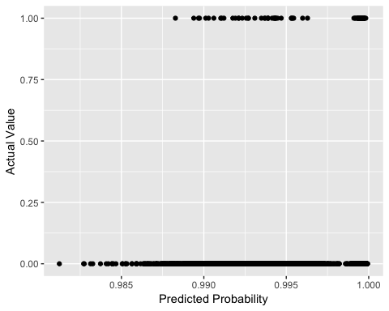

From this logitstf model:

1. The error table has the totally opposite result compared to the logistic model, which is not normal.
2. Prediction plot shows the same conclusion: the predicted probability higher than 0.99 but the majority of actual points are zeros.

#### c. stan_glm: Use MCMC method to fit logistic model

Bayesian method is also mentioned while talking about “Rare Event Problem”, because MCMC method is different from Maximum Likelihood Estimation process.

## stan_glm  
## family: binomial [logit]  
## formula: content_1 ~ as.factor(gender) + as.factor(affluency) + log(express.total.spend +   
## 1) + log(express.no.transactions + 1) + log(metro.total.spend +   
## 1) + log(metro.no.transactions + 1) + log(superstore.total.spend +   
## 1) + log(superstore.no.transactions + 1) + log(extra.total.spend +   
## 1) + log(extra.no.transactions + 1) + log(fandf.total.spend +   
## 1) + log(fandf.no.transactions + 1) + log(petrol.total.spend +   
## 1) + log(petrol.no.transactions + 1) + log(direct.total.spend +   
## 1) + log(direct.no.transactions + 1)  
## observations: 36849  
## predictors: 20  
## ------  
## Median MAD_SD  
## (Intercept) -4.1 0.7   
## as.factor(gender)Male -1.0 0.1   
## as.factor(affluency)Low -0.1 0.1   
## as.factor(affluency)Mid -0.1 0.1   
## as.factor(affluency)Very High 0.1 0.2   
## as.factor(affluency)Very Low -0.1 0.2   
## log(express.total.spend + 1) 0.1 0.0   
## log(express.no.transactions + 1) 0.0 0.1   
## log(metro.total.spend + 1) 0.0 0.0   
## log(metro.no.transactions + 1) 0.0 0.1   
## log(superstore.total.spend + 1) 0.0 0.0   
## log(superstore.no.transactions + 1) 0.0 0.1   
## log(extra.total.spend + 1) 0.0 0.0   
## log(extra.no.transactions + 1) -0.2 0.1   
## log(fandf.total.spend + 1) 0.0 0.0   
## log(fandf.no.transactions + 1) 0.0 0.1   
## log(petrol.total.spend + 1) 0.0 0.0   
## log(petrol.no.transactions + 1) 0.1 0.1   
## log(direct.total.spend + 1) 0.0 0.0   
## log(direct.no.transactions + 1) -0.1 0.1   
##   
## Sample avg. posterior predictive distribution of y:  
## Median MAD_SD  
## mean_PPD 0.0 0.0

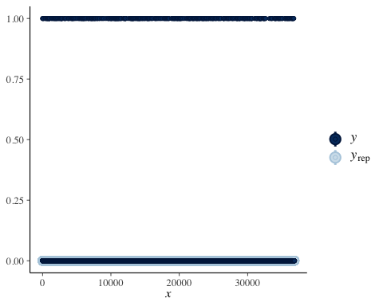

Limited to computational capability, I’ve set number of chains to 2 and number of iterations to 1000. Based on ppcheck plot, which is similar to the prediction plot, the problem still take place, because model’s return values are all located at zero while we have some data scatters at one.

In general, these three models designed to tackle rare data problem didn’t work out in this context, and I will be open to explore other solutions to this problem.

### iii. Multilevel Mixed Effect Model for Contents

It would also make sense to try multilevel mixed effect model. I’ll put gender and affluency, the only two factor variables in the data as random effects.

## Generalized linear mixed model fit by maximum likelihood (Laplace  
## Approximation) [glmerMod]  
## Family: binomial ( logit )  
## Formula:   
## content_1 ~ (1 | gender) + (1 | affluency) + scale(express.total.spend) +   
## scale(metro.total.spend) + scale(superstore.total.spend) +   
## scale(extra.total.spend) + scale(fandf.total.spend) + scale(petrol.total.spend) +   
## scale(direct.total.spend)  
## Data: data_train_nona  
##   
## AIC BIC logLik deviance df.resid   
## 4336.1 4421.3 -2158.1 4316.1 36839   
##   
## Scaled residuals:   
## Min 1Q Median 3Q Max   
## -0.2012 -0.1267 -0.0874 -0.0769 14.9243   
##   
## Random effects:  
## Groups Name Variance Std.Dev.   
## affluency (Intercept) 2.542e-10 1.594e-05  
## gender (Intercept) 2.544e-01 5.043e-01  
## Number of obs: 36849, groups: affluency, 5; gender, 2  
##   
## Fixed effects:  
## Estimate Std. Error z value Pr(>|z|)   
## (Intercept) -4.642385 0.361219 -12.852 <2e-16 ***  
## scale(express.total.spend) 0.046845 0.046970 0.997 0.319   
## scale(metro.total.spend) -0.036449 0.052916 -0.689 0.491   
## scale(superstore.total.spend) 0.053987 0.044876 1.203 0.229   
## scale(extra.total.spend) -0.095496 0.059605 -1.602 0.109   
## scale(fandf.total.spend) -0.007329 0.051341 -0.143 0.886   
## scale(petrol.total.spend) 0.034821 0.047397 0.735 0.463   
## scale(direct.total.spend) -0.055414 0.055294 -1.002 0.316   
## ---  
## Signif. codes: 0 '***' 0.001 '**' 0.01 '*' 0.05 '.' 0.1 ' ' 1

## $affluency  
## (Intercept)  
## High 2.159202e-09  
## Low -1.029648e-09  
## Mid -1.937542e-09  
## Very High 8.860451e-10  
## Very Low -7.216275e-11  
##   
## $gender  
## (Intercept)  
## Female 0.4997983  
## Male -0.4939002

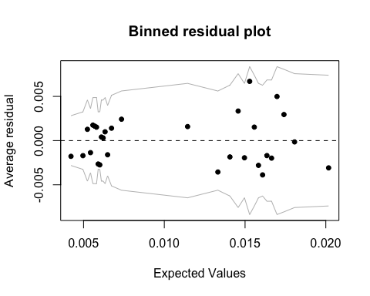

#Prediction Intervals Plot

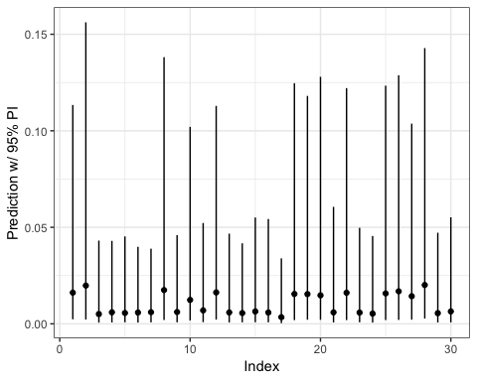

#Plot predicted value vs. actual value

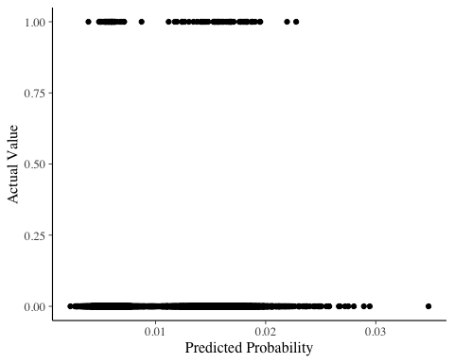

#Error table

## y_hat=0 y_hat=1  
## y=0 0.98917203 0  
## y=1 0.01082797 0

From this multilevel mixed effect model:

1. The affluency as a random effect doesn’t have a high influence on the model, with its coefficients really close to zero. While the gender effect relatively has a large difference. So I don’t think that adding levels to the model help me explain more about the response variable.
2. Binned residual plot of this model looks normal.
3. The predictions made on test set and the error table seem that it’s still suffering the same problem left before, known as “rare event” problem. The three models (multinomial, logistic and multilevel) are showing exactly same results in error table and predictions.

### iv. Models After Modifying Proportions Of 0s and 1s

Modifying the content_1 to 50% of ones and 50% of zeros, which may produce a more “real” prediction accuracy rate, but this data processing will lose the proportions’ information and I’m not sure if it will make sense because one of the most important messages conveyed from the data is the proportion of ones in content clicking choice.

## Call:  
## glm(formula = content_1 ~ as.factor(gender) + as.factor(affluency) +   
## log(express.total.spend + 1) + log(express.no.transactions +   
## 1) + log(metro.total.spend + 1) + log(metro.no.transactions +   
## 1) + log(superstore.total.spend + 1) + log(superstore.no.transactions +   
## 1) + log(extra.total.spend + 1) + log(extra.no.transactions +   
## 1) + log(fandf.total.spend + 1) + log(fandf.no.transactions +   
## 1) + log(petrol.total.spend + 1) + log(petrol.no.transactions +   
## 1) + log(direct.total.spend + 1) + log(direct.no.transactions +   
## 1), family = binomial, data = data_train_fifty)  
##   
## Deviance Residuals:   
## Min 1Q Median 3Q Max   
## -1.7203 -1.0763 0.7734 1.0447 1.8558   
##   
## Coefficients:  
## Estimate Std. Error z value Pr(>|z|)  
## (Intercept) -0.243645 1.236361 -0.197 0.8438  
## as.factor(gender)Male -1.094287 0.154299 -7.092 1.32e-12  
## as.factor(affluency)Low -0.454921 0.233297 -1.950 0.0512  
## as.factor(affluency)Mid -0.330392 0.199337 -1.657 0.0974  
## as.factor(affluency)Very High -0.469873 0.343554 -1.368 0.1714  
## as.factor(affluency)Very Low 0.150543 0.411719 0.366 0.7146  
## log(express.total.spend + 1) 0.099080 0.065684 1.508 0.1314  
## log(express.no.transactions + 1) 0.168541 0.158345 1.064 0.2872  
## log(metro.total.spend + 1) 0.093019 0.064233 1.448 0.1476  
## log(metro.no.transactions + 1) -0.248386 0.176357 -1.408 0.1590  
## log(superstore.total.spend + 1) 0.039502 0.061122 0.646 0.5181  
## log(superstore.no.transactions + 1) -0.011450 0.167235 -0.068 0.9454  
## log(extra.total.spend + 1) -0.022955 0.063934 -0.359 0.7196  
## log(extra.no.transactions + 1) 0.048466 0.157346 0.308 0.7581  
## log(fandf.total.spend + 1) 0.017614 0.062183 0.283 0.7770  
## log(fandf.no.transactions + 1) -0.036098 0.119801 -0.301 0.7632  
## log(petrol.total.spend + 1) 0.036823 0.061210 0.602 0.5474  
## log(petrol.no.transactions + 1) -0.036413 0.113357 -0.321 0.7480  
## log(direct.total.spend + 1) 0.002796 0.056493 0.049 0.9605  
## log(direct.no.transactions + 1) -0.079159 0.122563 -0.646 0.5184  
##   
## Null deviance: 1106.0 on 797 degrees of freedom  
## Residual deviance: 1036.6 on 778 degrees of freedom  
## AIC: 1076.6  
## Number of Fisher Scoring iterations: 4

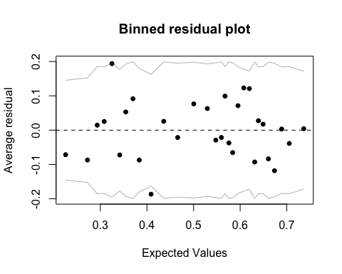

#Anova test

Df Deviance Resid. Df Resid. Dev  
## NULL 797 1106.0  
## as.factor(gender) 1 51.697 796 1054.3  
## as.factor(affluency) 4 5.605 792 1048.7  
## log(express.total.spend + 1) 1 5.544 791 1043.2  
## log(express.no.transactions + 1) 1 1.232 790 1041.9  
## log(metro.total.spend + 1) 1 0.987 789 1041.0  
## log(metro.no.transactions + 1) 1 2.083 788 1038.9  
## log(superstore.total.spend + 1) 1 0.550 787 1038.3  
## log(superstore.no.transactions + 1) 1 0.005 786 1038.3  
## log(extra.total.spend + 1) 1 0.091 785 1038.2  
## log(extra.no.transactions + 1) 1 0.066 784 1038.2  
## log(fandf.total.spend + 1) 1 0.016 783 1038.1  
## log(fandf.no.transactions + 1) 1 0.111 782 1038.0  
## log(petrol.total.spend + 1) 1 0.336 781 1037.7  
## log(petrol.no.transactions + 1) 1 0.100 780 1037.6  
## log(direct.total.spend + 1) 1 0.585 779 1037.0  
## log(direct.no.transactions + 1) 1 0.418 778 1036.6

#Model assumptions check

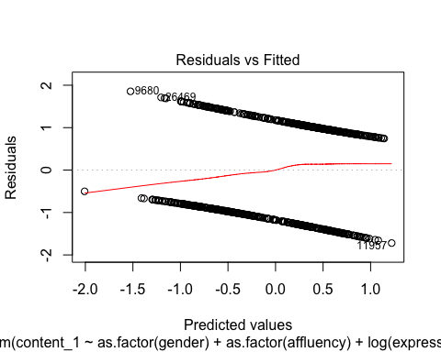 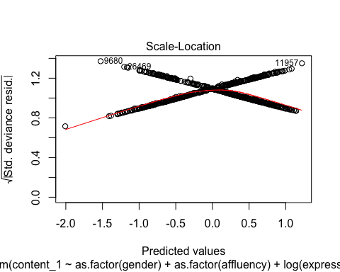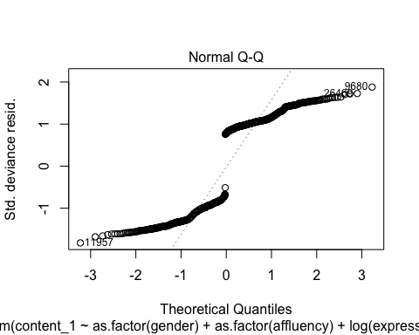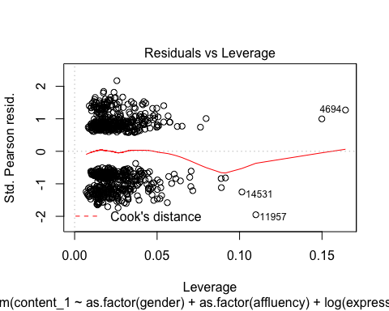

#Error table  
## y_hat=0 y_hat=1  
## y=0 0.2731830 0.2180451  
## y=1 0.1441103 0.3646617

#Predictions  
#In prediction, I'll still use the whole test set without manipulating the proportions of zeros and ones on the test data.

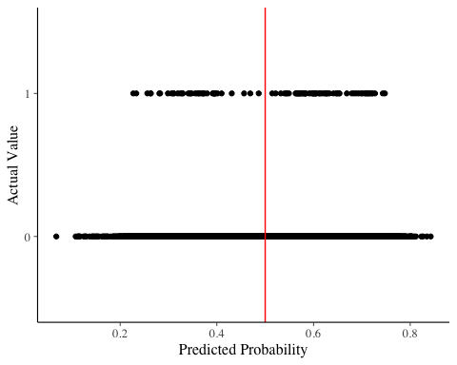

From this logistic model:

1. We’re not confident that the variables put in the model are explaining the response variable well, which may decrease the prediction accuracy;
2. The anova test results tell us that adding some variables (such as superstore.no.transactions, extra.no.transactions, etc) didn’t improve the model’s explainability a lot;
3. From model assumption check plots, the model’s residuals are not normal distributed (points are far from located on the line); the residuals aren’t spread equally along the ranges of predictors (a weird cross on the plot); and no influencial cases in this case;
4. The binned residual plot proves the absence of heteroscedasticity;
5. With modified data, the error table returns a “normal” result, 63% accuracy rate in train data. And the prediction plot’s x-axis, prediction values, now has a range from 0 to 1 (compared to 0 to 0.1 before), and it means that the data modification solves the problem suffered before;
6. This result also prove on the one side, the data will cause “rare event” problem to the models, even though this model result (after modifying data’s proportion) is limited in usage; On the other side, the fact that previous models don’t explain the response variable well is not largely due to the “rare event” problem, it’s due to the variables’ selection problem.

# E. Discussion

## i. Implitcation

From all the results and the interpretations of the models fitted above, it’s not reasonable to use these models to predict clicking rate; while the models do explain the clicking rate to some extend.

## ii. Limitation

1. The “rare event” problem is not resolved in this project, which will constraint the models proceeding predictions.
2. The data is random simulated by the company with some latent assumptions, which are not disclosed to data users. These assumptions are supposed to be discovered by learning results, but in my project, they have not been identified. This can potentialy be solved when I’ve learnt more about machine learning.

## iii. Future Directions

1. I may continue on looking for other methods which could resolve the rare event problem in this dataset.
2. The data’s structure or other latent relations may violate the assumptions of regressions I’m applying in the project. Therefore, some other more advanced learning methods may be more appropriate for this data’s predicting problem.
3. After finding a more proper and efficient way to make predictions, I will continue on predicting content_2 to content_9.

# Appendix:

## I. Other EDA Plots

### 1. Total amount of transactions vs. Affluency

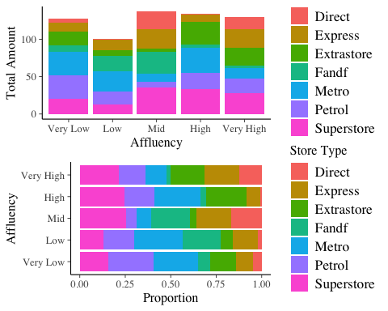

### 2. Number of transactions vs. Affluency

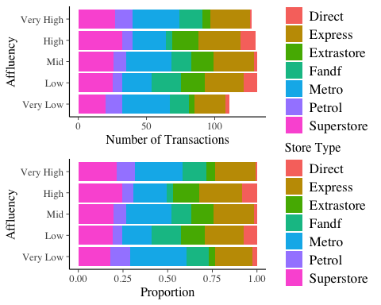

### 3. Total amount of transactions vs. Gender

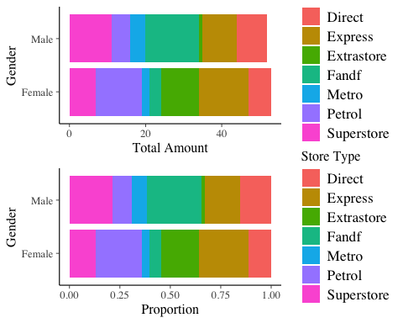

### 4. Number of transactions vs. Gender

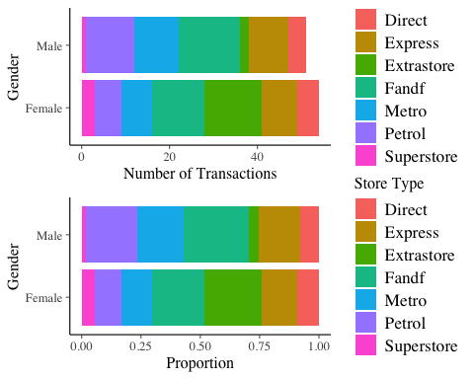

## II. Another Method on Data Preprocessing

I’ve first use the data with all observations to fit all three regression models, which means the NAs have not been removed. The results were similar: all three model’s explaning abilities on the content_1 clicking rate were good but the models predicted each output (no matter the values of variables) to be zero, because of the rare event problem, which means that the training dataset has overwhelming amount of zeros compared to ones for content_1. I then think of deleting NA at the beginning, because after deleting the NAs, the proportion of ones will increase a little bit (but finally found out that this was not sufficient).

## III. Statistical Learning Methods Used in the Project

For this project, after getting these results, I’ve applied some learning methods which can potentially be helpful:

1. Gradient Boosting Decision Tree: <https://www.r-bloggers.com/gradient-boosting-in-r/> It was used to deal with the “rare event” problem, but I had a hard time interpreting the results and I was not sure about if the whole process was correct or not, so I didn’t put it into the report.
2. Neural Network: <https://www.r-bloggers.com/fitting-a-neural-network-in-r-neuralnet-package/> Depending on my understanding, neural network can handle some latent, complexe and multi-layer relations, which may be useful on identig the company’s inital assumptions on the simulations. But I think I need to spend more time learning its concepts and package to have a whole picture understanding before applying it to data.

# References:

[1]: <https://turi.com/learn/gallery/notebooks/click_through_rate_prediction_intro.html>

[2]: <https://www3.nd.edu/~rwilliam/stats3/rareevents.pdf>

[3]: <https://www.r-bloggers.com/example-8-15-firth-logistic-regression/>

[4]: <https://www.r-bloggers.com/making-sense-of-logarithmic-loss/>

[5]: <https://cran.r-project.org/web/packages/brglm/brglm.pdf>

[6]: <https://stats.stackexchange.com/questions/354084/modelling-rare-events-with-small-sample-size>